Explanation of how to get data for 22_bzone_employment.csv
March 10, 2026
Definition of the Input File
VisionEval (https://visioneval.github.io/docs/model-inputs.html) explains that this file has three types of employment--total, retail and service—where the cagtegories are based on EPA’s Smart Location Database. These values are shown below for three bzones: 515400010001 (an urban area near Charlottesville’s downtown pedestrian mall) with large amounts of employment, 510030107021 (a suburban area near Route 29 in Albemarle County with some employment), and 510030110004 (a rural residential area in Albemarle County). Not surprisingly employment is largest in the most urban zone.
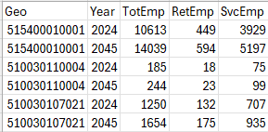
Possible Scenario
Transportation is a derived demand, and generally two of those drivers are population and employment, such that all other things being equal, one would expect some type of change in employment to increase travel demand. However, as noted in the document Task 7.2 Simplified Scenario Development guide, available at A Playbook for Simplified Approaches for Creating Scenarios in VisionEval, employment also is a land use factor in that land use is based on, in part, the degree of mix. Thus while one scenario is to see how an increase in employment without changing land use mix will increase VMT, emissions, congestion, and transit use, a second scenario is to see how redistribution of employment influences land use mix where in turn increases in the degree of land use mix could influence demand for pedestrian, bicycle, or transit travel.
Method Used for Virginia
Getting data for year 2022
Employment data were obtained from the Longitudinal Employer-Household Dynamics website which provides, at the block level, total jobs for year 2022 (U.S. Census Bureau, 2025). Because blocks use 15 characters (e.g., blocks “510010901011006” and “510010901011011”) whereas block groups use 12 characters (e.g., both of these are in block group 510010901011), the data could readily be processed in Excel such that the 3,793,766 Virginia jobs for year 2022 are organized by block group. For example, for block group 510010901012, the U.S. Census Bureau (2025) lists three blocks as shown in Table 1. Thus, the total jobs for block group 510010901012 is 115+1+3=119.
Table 1. Example of Jobs Available from U.S. Census Bureau (2025)
Block | Jobs
510010901012000 | 115
510010901012010 | 1
510010901012013 | 3

As shown in the VisionEval help menu (https://visioneval.github.io/docs/model-inputs.html#verspm-bzone_employment.csv) retail employment is based on “Number of jobs in retail sector in zone (Census LEHD: CNS07)” and service employment is based on “(Census LEHD: CNS12 + CNS14 + CNS15 + CNS16 + CNS19).” These attributes are given directly in the LEHD data. Thus one ends up with Table 2 for year 2022 for bock group 510010901012.
Table 2. Total, Retail, and Service Employment for Block Group 510010901012 as of 2022
Block Group | TotEmp | RetEmp | SvcEmp
510010901012 | 119 | 14 | 6

Converting data to years 2024 and 2045
Total employment data (in thousands) were obtained from Woods & Poole Economics, Inc. (2024) which provides data for either each city (e.g., City of Virginia Beach), each county (e.g., Accomack County), or in some cases, groups of 2-3 cities and counties (e.g., Fairfax City plus Fairfax County plus Falls Church City). These data are given for years 2024 and 2045. Data had been disaggregated to each city and county (Gillespie, 2024) and then these 2024 and 2045 values, relative to 2022, were used as multipliers for each Bzone. For example, block group 510010901012 is located in Accomack County. Table 3 shows Accomack County total employment as increasing by aby 1.4% from year 2022 to 2045 and by about 14.4% from year 2022 to year 2045.
Table 3. Forecast Changes in Employment for Accomack County (2022-2045)
Locality | BEA_ID | 2022 jobs (thousands) | 2024 jobs (thousands) | 2045 jobs (thousands) | 2024 Multiplier | 2045 Multiplier
Accomack | 51001 | 18.769 | 19.035 | 21.471 | 1.014 | 1.144

Accordingly, the ratios shown Table 3 are used with the data in Table 1 to develop total, service, and retail employment for years 2024 and 2045 for bock group 510010901012.
Table 4. Data for Block Group 510010901012 for Years 2024 and 2045
Year | TotEmp | RetEmp | SvcEmp
2022 (from Table 1) | 119 | 14 | 6
2024 | 121 | 14 | 6
2045 | 136 | 16 | 7

Missing Zones
There are a total of 5,963 block groups in Virginia—yet the bzone employment file has only 5,939 block groups. That is, there are 24 block groups where no employment data are available. Figure 1 shows that these 24 block groups are special cases consisting of (1) a portion of Radford University, (2) a portion of the Radford AAP Main Manufacturing Area, and (3) several water areas in Hampton Roads. For now, employment for all of these areas was set to zero.
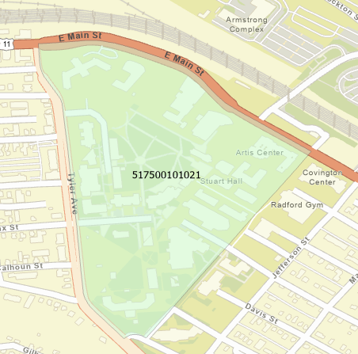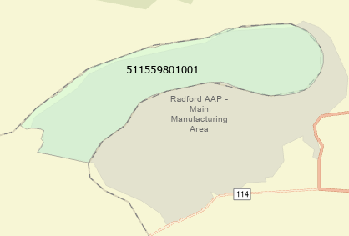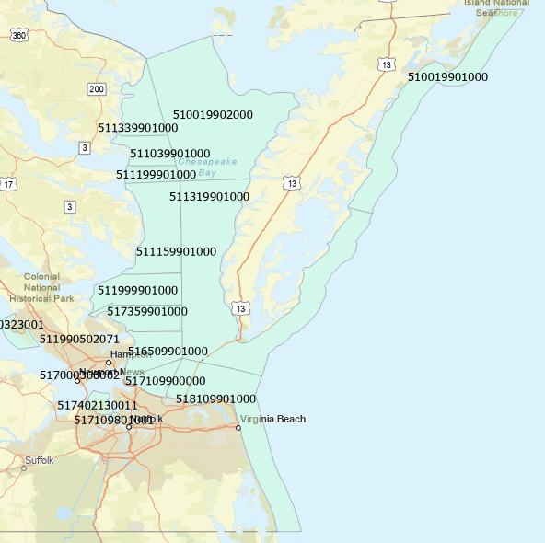
Figure 1. Zones where Employment is Set to Zero
Thus, for every bzone CSV file there is one header row followed by 5,963 rows of 2024 data followed by 5,963 rows of 2045 data, such that every Bzone CSV file should have a total of 5,963+5,963+1=11,927 rows.
Three files have been uploaded.
- 22_bzone_employment.docx (this file) has the documentation.
- 22_bzone_employment.xlsx has the processing in case John made an error and includes a ReadMe tab
- 22_bzone_employment.csv has the final answer.
Potential Future Enhancements
There are two ways to improve this approach in future years.
- The data that were used were purchased from Woods & Poole in 2024, as these had already been processed by VTRC. Woods & Poole updates these data annually, thus updated forecasts from year 2025 or 2026 could be purchased.
- The multipliers given in Table 3 are based on total employment, which makes sense for the variable “TotEmp.” One could argue, of course, that service employment and retail employment in a given city or county are not forecast to increase at the same rate as total employment. Thus with additional processing, one could use individual two-digit NAICS codes to develop different multipliers for “RetEmp” and “SvcEmp.”
One reason for not pursuing the two bullets at this time is that for the 2024 data, VTRC purchased the right to share certain variables publicly from Woods & Poole—one of which was 2024 total employment. Thus the data used herein can be shared with others, in case questions arise.
References
Gillespie, J.S. Email to J. Ramchandani, September 6, 2024.
U.S. Census Bureau. Longitudinal Employer-Household Dynamics. Washington, D.C., 2025. https://lehd.ces.census.gov/data/. Accessed November 3, 2025.
Woods & Poole Economics, Inc. 2024 State Profile: District of Columbia, Maryland, and Virginia. Washington, D.C., 2024.

SCRAP Work—No need to read this but this helps John remember key items
Data - Longitudinal Employer-Household Dynamics
LODES Technical Document Version 8.3
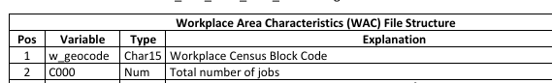
Understanding Geographic Identifiers (GEOIDs)
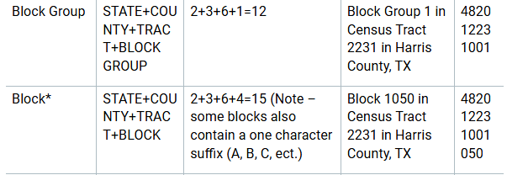
- Relationship between Bzones and real data in Virginia
- A Bzone will look something like this: “518100462251”
- The first 2 digits (“51”) indicate the state is Virginia
- The 3 digit code in red after the 51 indicates the city or county. For example, because the code is 810, we know that this is Virginia Beach City.
- The meaning of the 3 digit codes for the Bzones are at this location: www2.census.gov/geo/docs/reference/codes2020/cou/st51_va_cou2020.txt
C:\Users\John.Miller1\Commonwealth of Virginia\TM-VDOT-VTRC EPE - Documents\TeamStuff\ProjectStuff\Summer2024\VTrans\Moruza_OneDrive_2024-03-18\Woods & Poole _ VTrans_2025\Local - Example workbooks
C:\Users\John.Miller1\Commonwealth of Virginia\TM-VDOT-VTRC EPE - Documents\TeamStuff\TemporaryStuff\WoodsPoole\Woods&Poole2024\SP_2024_DC_MD_VA.zip\WP_Download_2024\SP_2024_DC_MD_VA
